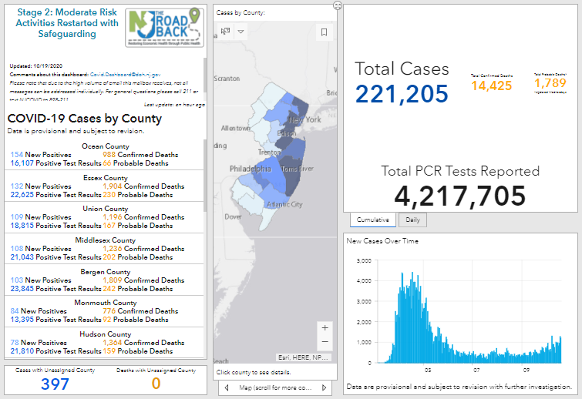

Pitt Student Coronavirus Dashboard

Important Current Announcement: Pitt is moving into Guarded Risk mode. Click Here to read more

Image or color background

Play Our Exciting New Game: *Name of Game*

Test Your Knowledge

Read Our Updated FAQs

Check Your Symptoms

Contact Us